Code Review: I2210022
Reviewer: Mark Dell
Date: June 6th, 2023

Bugs
- The ScrollBarLook.ButtonAppearance.ForeColor was intentionally changed to TextColor from Color.White for I2203305 after a short discussion with James, but was changed back with this ticket. Was there a reason for that?
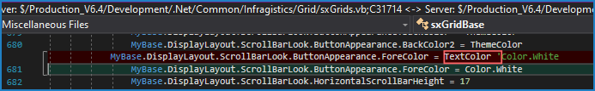
- Nit: A settings conflict exists in the code, and the final value was set two times. The HeaderStyle was set to WindowsVista and then later set to WindowsXPCommand. Note that other than the duplication, this conflict existed in the old code, and as such is marked here as a Nit, instead of a full bug. If there is an actual reason to do this, then a code comment should note that.
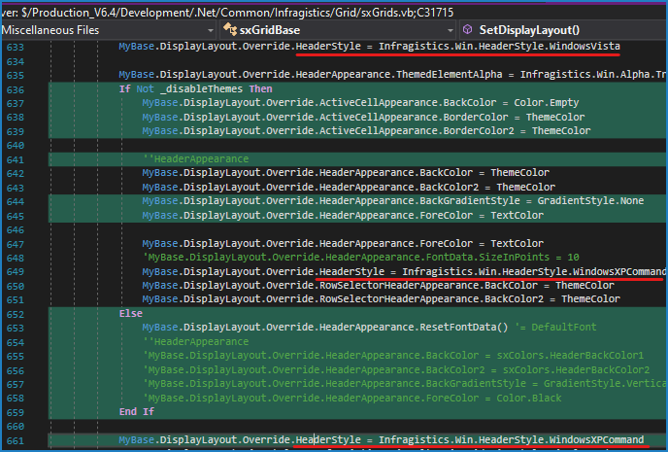

Preventative Action/Safety

Design/Architecture (Duplication, appropriate project, namespaces, maintainability)

Data Model (Naming, good design, needs index?)

Performance (Minimize DB hits, excessive loops, queries, scalable)

UI (Alignment, naming, standardization, tab order)

Error Handling (Behind events, appropriate parameter checking)

Cleanup (Dispose code, remove handlers, large data objects)

Readability (Well-named variables, methods, clear algorithm, is it understandable)
- Nit: When modifying code, we rarely comment out the old code anymore (line 1671 & 1674 of image below). Instead, we just remove it, and some put a reference to the ticket number that it was modified for. There are other instances in the changes checked in for this.
Keeping the old code is partly a holdover from before we had TFS, and it has been decided that it is no longer warranted. TFS should help us enough that we don’t need to keep a bunch of old, commented out code lying around our codebase. If an exception to this is needed, a comment should be included in the code explaining why.
- Nit: Since I find spacing improves this, I usually add a line break before Try, If, Do, While, Else, and ElseIf type statements when they are not indented from the previous line. I do not add a blank line after the end of those flow control statements when it is outdented from another. I may exclude doing that for Else statements when the “If … End If” is very small and not solely contained within another structure (see the marked lines in the image). There are other instances in the changes checked in for this.
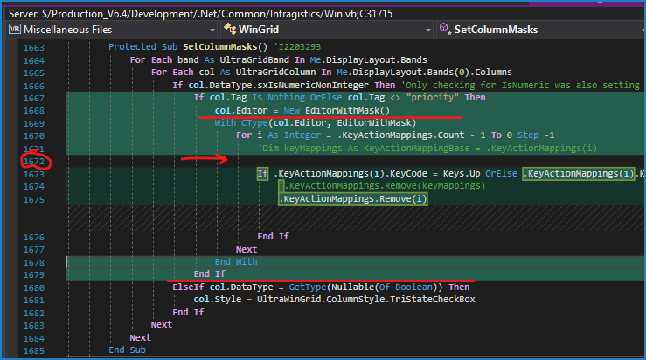

Comments (Useful, explains why rather than how)

Message Boxes (Grammar, spelling, captions, appropriate icons)

Ticket Management (Release Branch?, Testing Notes)

Extras

